**Debbie Sleeper**

**Game Proposal –Mess up Dress up!**

**Description**

Click the corresponding clothes for the setting provided to put on the user. Hit submit and see if you win! complete

**User Stories:**

As a user I'd like to preview my selections before I choose them. complete

As a user I'd like to know if I won so I can be proud. complete

As a user I'd like to have my avatar react to my selections so I can have a hint. complete

As a user I'd like to have a variety of clothing options so I can be creative. complete

**MVP:**

User is provided with a place and 9-16 items of clothing to choose from. complete

User has ability to select 3-4 clothing items for their avatar. complete

User is told if they selected the correct items – i.e. if they won. complete

**The Places (different backgrounds)**

Red Carpet – Goal 1 complete

Wild West -MVP complete

Beach – Goal 3 complete

Space – Goal 2 complete

**Clothes**

Hats – cowboy, tiara, beach hat, helmet, - same m/f complete

Main Dress – ball gown (f) ~~tux - male~~, space suit, bathing suit(f) trunks (m), ~~vest with fringe shirt~~ and fringe pants. complete

Shoes – cowboy boots, high heels, ~~flip flops~~, space boots complete

~~Item – lasso, sunglasses, corsage, gloves~~

**Avatar**

~~Male – short hair, will automatically use tux~~

Female – Hair longer, will automatically use dress complete

need head, torso, arms and legs complete

**Avatar face expressions**

*Smile* - standard, complete

*Very Happy* – clothing items are matching -*Excited* – on win complete

*Concerned* – clothing items are not matching - *Horrified* – on lose complete

**Winning –**

To win must have 100% 30% for each clothing, ~~10% for the accessory~~ complete

100% Great job! ~~Avatar bounces~~ music plays

If 50% or above, Good try. music plays

30 – 50% Not quite music plays

Below 30% ~~Ouch! Avatar Explodes~~ music plays

**Settings:**

Start in bedroom. ~~Closet clickable~~.

~~On click go to closet – new page~~

Items all in closet. ~~When you hover they get big (like a gallery).~~

On select ~~go back to room and~~ item is on avatar complete

Avatars expression is changed depending on the item. complete

On submit button calculate percent and display results. complete

Background will change to the place. complete

Next setting will come up if player hits next. complete

* Introduction
  + Tell us what the game is, how to play it, etc.

The game involves choosing clothes for your avatar from a selection to match a proposed setting. If you pick the right clothes you win. If you don’t, you lose.

* Technologies
  + Tell us, on a high-level what technologies you are going to use to build the game
    - HTML, CSS, Javascript. The avatar will be made from CSS div shapes. Clothing selection will be in the closet but act like a gallery. On mouseover item will be enlarged. On click it will be added to the avatar. On click again it will be removed. Submit button will run the win logic. Face of avatar will hopefully react to the selection.
    - Tell us how you plan on implementing the difficult parts
    - I will need to research a bit on how to show the clothing options in a way that is intuitive and easy to access for the user. Might need to use scrollbar or other methodologies.
    - I’d like to have some kind of movie items in the background of the setting that would react to the avatar, but this is a goal not a must have.
* MVP
  + Tell us what you *must have* for the project to work
    - The avatar, at least 6 clothing options, the background swap and the win logic.
* Goals
  + Tell us what you would *like to have* after you reach your MVP
    - Face reaction, option to switch between male and female and choose skin color, hair color.
* Stretch Goals
  + Tell us what you would like to get to, if time were no issue. You should not expect to reach these.
    - Have some kind of moving characters in the background that react to the avatar’s clothing selection - Smiling or looking horrified.
* Timeline
  + What do you need to have done by each night:
  + Monday night?
    - By Monday the basic avatar should be in place along with the clothing items. I’d like to get some logic in of adding the clothes to the avatar’s body in the correct places and removing them.

Tuesday Night

* + - By Tuesday I’d like to build out the win logic and the actions that follow it, as well as the skin color, ~~male and female change~~ and hair color options and face changes
  + Wednesday night?
    - By Wednesday I’d like to start with some of the extra items such as adding more backgrounds to keep the game going on different levels.

Thursday night?

* + - Any cleanups, touch ups, fixes or if all is good, the extra goals.
  + This should be detailed
  + You do not have to stick with this timeline but should use it as a guide
* Wireframes
  + You can use whatever you want to make these (it can just be a drawing)
  + This must be checked into your repo and displayed in this section
  + If it's a drawing you can take a picture with your phone and upload it.

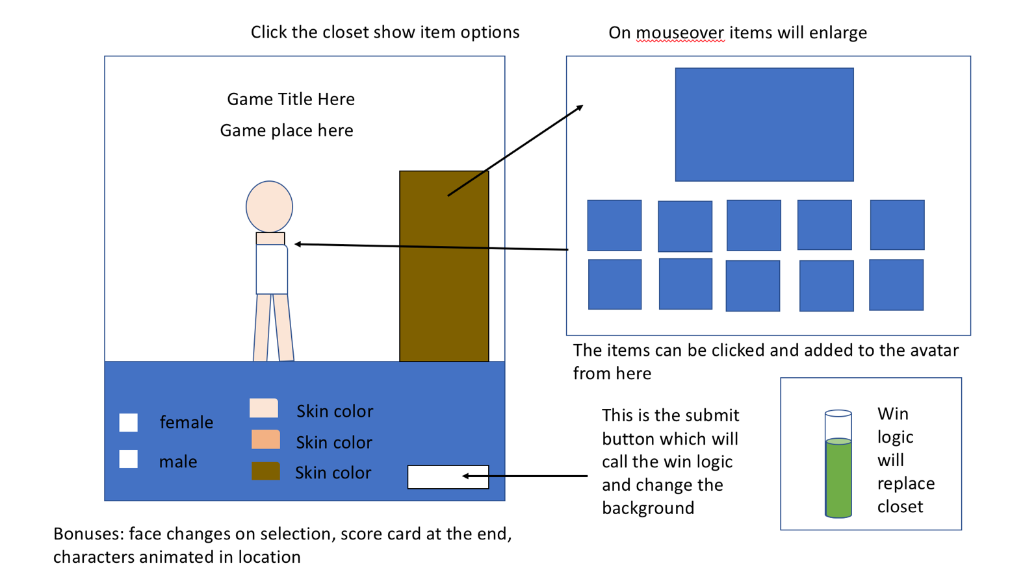

Logic pieces:

On load I will need to assign click events to the closet and submit button.

On clicking the closet, gallery should open up and click events should be assigned to all clothing items – both to add and remove. On mouseover each clothing item should enlarge.

On click of each clothing item the face logic will need to run and item will be applied to the avatar in the correct location.

On submit, win logic will run looking at each clothing item to do the calculation.

Next button will populate with a click event to load the next scene.

Specs

* **Render a game in the browser**
* **Design logic for winning** & **visually display when the game is won or lost**
* **Include separate HTML / CSS / JavaScript files**
* Stick with **KISS (Keep It Simple Silly)** and **DRY (Don't Repeat Yourself)** principles
* Use **Vanilla Javascript or jQuery** for **DOM manipulation**
  + Do not have a heavy mix of both
  + If you are using Vanilla JS: we should see no $
  + If you are using jQuery: we should see no document
* **Deploy your game on Github Pages**
* Use **semantic markup** for HTML and CSS (adhere to best practices)
  + You may **not** Bootstrap for this project (you will be able to do this for later projects)
* Have at least 10 commits
  + You will likely have many more. But we are forcing you to get in the habit of committing
* Have code that we can read. If the indentation is all over place, variable / function names that don't make sense, etc. then we cannot read your code. We have to read your code in order to grade it.
* A README.md (see below)
* **Absolutely no Disney IP**. If you have any doubts, do not use it
  + This is a reminder. This goes for every assignment

Retrospective:

1. What went well?

I was pleased that my project turned out more or less exactly like my wireframe which means I had a good understanding of what I was capable of doing.

People seemed to enjoy my game and have fun playing it.

My time management worked really well and I was able to add one or two extra things into my game.

1. What didn't go so well?

I wanted to make my character move around but as she was made up of divs in CSS and wrapped in a container I was unable to animate her – only the container.

I should have made my clothes images draggable. Everyone keeps trying to drag them.

The ‘boots’ or ‘shoes’ don’t really look like boots or shoes. I had to write on them for the user to know what they were.

My presentation went ok but I should have learned how to zoom in on a mac. As a result my spacing was a bit off throughout.

1. What did we learn?

I learned a lot of new things - how to animate html elements in JQuery, how to format the background image to look ok, how to make a person out of CSS, how to work with updating variables throughout the game so that skin and hair color could change, I was able to reduce my code by about 300 lines by taking out changeable strings, making them variables and changing everything into for loop functions that looped through objects which contained those variables. I learned how to add music.

I became much more comfortable working in JQuery and CSS whereas before I had hated both. This project took me out of my comfort zone.